REPORT ON GROCERY WEBSITE

MEMBERS – SHUBHAM RAJ (ROLL NO. 27),

KUMAR RAJ (ROLL NO. 28).

SUBJECT – INTERNET PROGRAMMING

LABORATORY (CSE 326)

SECTION – K22RZ

TEACHER’S NAME – DR. MOHAMMAD FAIZ

Acknowledgement

I would like to express my special thanks of gratitude to sir DR. Mohammad Faiz for their able guidance and support in completing my project of grocery website.

Secondly, I would also like to thank my friends who helped me a lot in finalizing this project within the limited time frame. The support given by University administration have also encouraged me throughout the project completion.

Introduction

Online grocery shopping is a form of electronic commerce where the buyer is directly online to seller’s computer usually via the internet. There is no intermediary Service. The Sale and purchase transaction is completely electronically and interactively which saves a lot of time of the user. So customer can easily shop according to the need of different recipes.

Nowadays online shopping site are quite famous within the peoples. Due to busy schedule of the people they don’t have much time to purchase manually so the online website acts as boon to the customers. It is efficient and user friendly.

Abstract

Our Project is a Grocery Website Which give Customers a user friendly interface and have multiple features for purchasing the Food, Vegetables. The Internet Revolution has made our life easy and fast. With help of internet Service customers has various options to surf and purchase the items. This Website also allows User to buy groceries online which are needed in day to day life without any difficult.

User can view the products and price of it. Online payment option is also available by various means depending on the customers. User can shop at any time of the day or night at their convenience. Special Discounts have also been Given in Special Products. User have options of online delivery which will save their time.

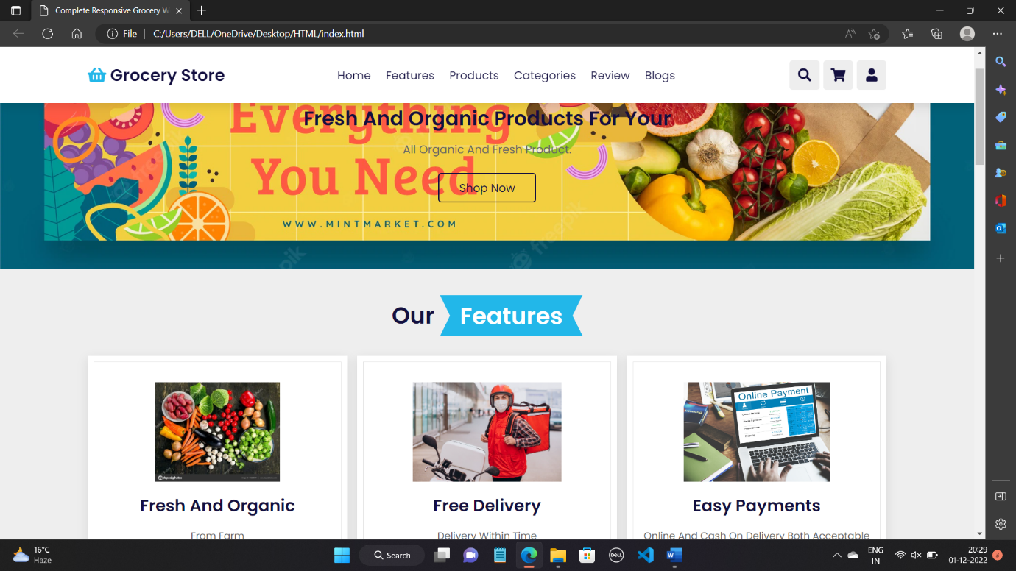

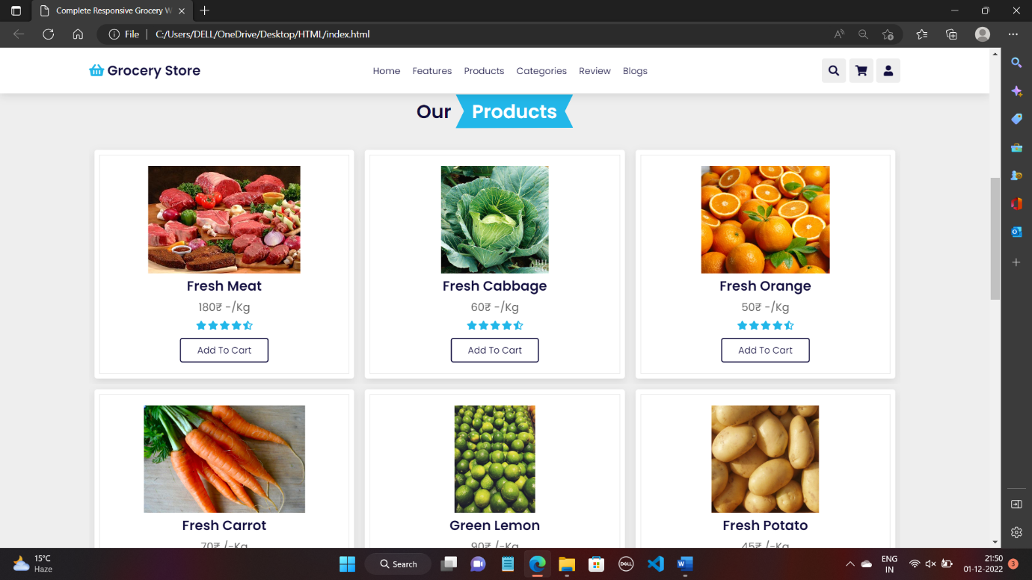

Project description

Home:- User have a quick glance of whole website. They can go to any link they want.

Features:- In this user can find the multiple features which is provided by the website such as Fresh and organic products, online delivery and easy payments. Users can have quick access through this links.

Products:- Customers have been provided various sample of items so they can purchase the item of their need. The suitable prices have been also mentioned in the products.

PRODUCTS CATEGORIES:- The various products are divided on the basis of requirement of the persons such as fruits, vegetables and dairy products.

Review:- Customers who have been benefited by this website have given their Precious words and rating in this section so the new user can have a trust on this website. Review sections always play a vital role in success of any website and company.

Login page:- the users have their own user id and password to login into the website. It is a very safe site for login through your personal details. If any user forgets its password so they can use Forget Password. The user which do not have account can also make account in this.

Hardware:-

Processor- 12th Gen Intel(R) Core(TM) i5-1235U 1.30 GHz

RAM- 8 GB

Windows- 11

SSD – 512 GB

TECHNOLIES USED:-

HTML

CSS

JAVA SCRIPT

NOVELTY

In today time the people life has been hectic and busy they do not get time to visit the shops and markets frequently. Many times they don’t get the desired products they want or if they get the price is not reasonable.

Grocery online website provides a good system of purchasing the items in a simple way which is very less time consuming. The prices are also very less than the offline products. User have option of online payment. The products are divided into various sections.

People are moving to online shopping sites frequently. So if they get a good website it will help them very much.

Proposed model and future

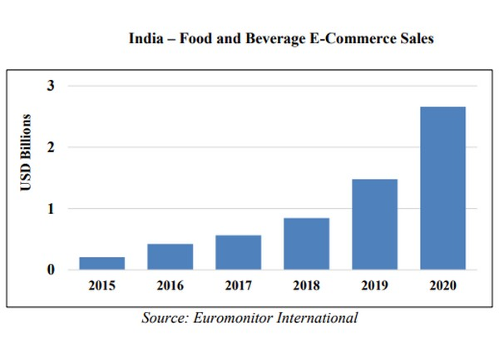

As seen above in the graph the people using online shopping websites are rapidly increasing. As the 5G network has already started the demand of this websites will also increase. In future we can some new features in our websites to make it more easily accessible. Such as tracking your order in which Customers can also have a track of their order in how much time it will get delivered.

We will add a feature in which customers can give us suggestion to make our website more attractive.

Conclusion

So we have created a user friendly, secure and a reliable website they will able to buy and access the products easily. User has own id and password so no other can use their account for any unfair practices.

Thank you